**2024 Ashley/Rakahuri Bird Survey Report**

The survey was done in cool, cloudy and breezy conditions with some showers later on. Flow in the river was very low (just over 7 cumecs at the gorge) and it was very easy to find places to cross it. There were about 20 surveyors.

The graphs below show that the numbers of braided river birds held up well in comparison to the last few years and are above the average for surveys since 2000.

BBG numbers are not shown on these graphs as they are extremely variable. If there is a colony, their numbers can overwhelm all else. Other years there are usually just a few scattered along the river and no trends in numbers are evident.

Given the weed cover, numbers held up very well, this would probably have been due to floods in the Waimakariri displacing birds across. The graph below shows recent floods in the Waimakariri which would be sufficient for birds to lose their nests and potentially relocate to the Ashley. Without the weed here, perhaps we would have equaled or exceeded the 2019 numbers. The survey was sufficiently later than the 26 October flood in the Ashley for it to have little relevance.

*Flow in Waimakariri (stage) and Ashley (cumecs) Rivers*

The next two maps show the distribution of birds by kilometre along the river. Numbers from the last two kilometres are not included in our annual statistics. Last year, with less weed, birds were more evenly distributed. This year there was more concentration in better braided sections of the river where we had cleared weeds.

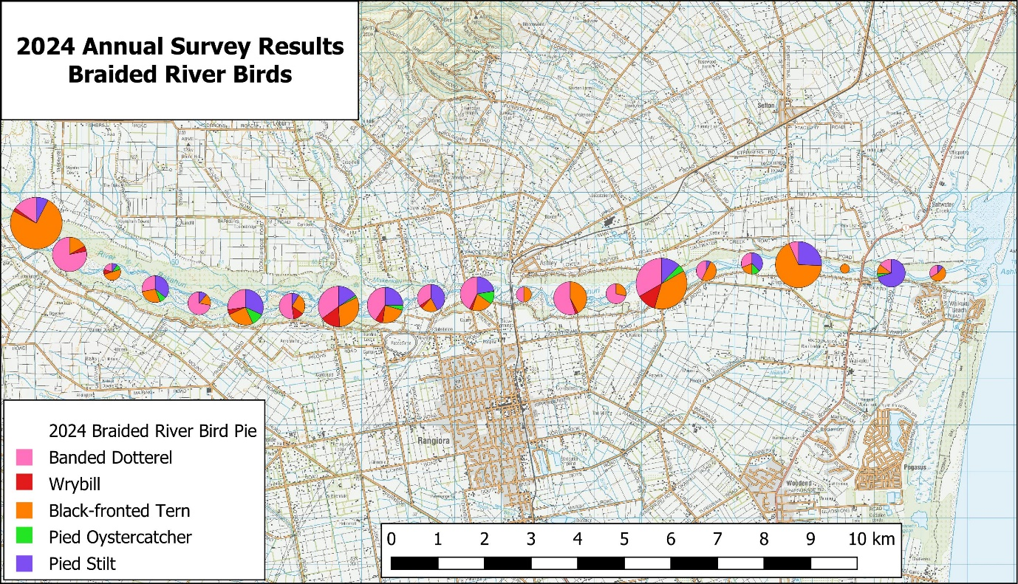

Braided River Bird Comments:

* Wrybill numbers were slightly down on last year, but still at a very good level. Recent observations of wrybill show how mobile they are, for example recently a banded female moved 7km between Smarts and Groyne 2 over several hours even when it had a chick at the former location. Another bird was seen in one location, then half an hour later flew in several hundred metres upstream, from an upstream direction. An accurate count of this, and other species, is difficult. Recently, as happened last year, several adult wrybill have been seen, often in small flocks, in the nesting territories of other birds. The number of wrybill counted isn’t a very good reflection of nest numbers.
* BD numbers were down from the record high last year – but to an average level.
* BFT numbers were up – this would be partly due to the lack of nesting habitat above the Okuku junction this year – to much weed there. BFT numbers and distribution would have been a little different a few weeks ago. The flood of 26 October took away almost all the nests from colonies at the Okuku junction and at Smarts. Then colonies were decimated by Norway rats (near Km 8) and a cat (near Groyne 2). At the time of the survey, nesting had started again at Smarts and the Okuku junction.
* PS and SIPO numbers were down slightly, but still at historically OK levels.
* There were 13 BBG counted vs 17 last year and 4097 in 2020. At the time of the survey there was a large colony where the river meets the estuary, with some 1,400 birds counted recently.

Other Bird Species Comments:

* Black-backed gull numbers were higher this year than last year, and at 18 the highest since 2010. We will have to watch for them nesting along the river as destruction of their nests at the estuary might displace them upstream.
* Black shag numbers were up (11 vs 3 last year) and little shag numbers down (13 vs 25). However, there will probably have been some misidentification of these species.
* Spur-winged plover numbers were very low – 9 vs 77 last year and 204 the year before.
* Duck numbers (26) were a little lower than usual, as were paradise duck numbers (90 vs 151 in 2023).
* There were fewer white-faced herons than last year – 5 vs 10 in 2023.
* Black-fronted dotterel numbers (3) were similar to usual. This is a species that many of our surveyors wouldn’t recognize.

Other comments

* As usual around 50% of our surveyors had never done a survey before. This is very disappointing, and we need to encourage repeaters. Instead of just calling for volunteers, we need to target previous surveyors. If this doesn’t work, we should consider doing some training the week before the survey.
* The quality of the surveying was probably very much the same as in previous years.